**Visvesvaraya Technological University**



# Belgaum, Karnataka- 590014

### A Mini Project Report On

**“Car Showroom Management”**

### BACHELOR OF ENGINEERING

In

### INFORMATION SCIENCE AND ENGINEERING

Submitted by

**Abhijeet Kumar (IDS19IS002) Apoorva S V (IDS10IS020)**

Under the Guidance of

**Mr.Sureshkumar M Mrs. Krupashankari S S**

Asst. Professor, Dept. of ISE Asst. Professor, Dept. of ISE

2021-2022

**DEPARTMENT OF INFORMATION SCIENCE AND ENGINEERING**

**DAYANANDA SAGAR COLLEGE OF ENGINEERING**

**SHAVIGE MALLESHWARA HILLS, KUMARASWAMY LAYOUT, BANGALORE-78**

# DAYANANDA SAGAR COLLEGE OF ENGINEERING



### Shavige Malleshwara Hills, Kumaraswamy Layout

##### Bangalore-560078

**Department of Information Science and Engineering**

**ACCREDITED BY NBA**

2021-2022

# Certificate

#### This is to certify that the Project Work entitled **“Car Showroom Management System”** is a bonafide work carried out by **Abhijeet Kumar (IDS19IS002) and Apoorva S V (IDS10IS020)** in partial fulfillment for the 5th semester Bachelor of Engineering in Information Science & Engineering of the Visvesvaraya Technological University, Belgaum during the year 2021 - 2022. The Project Report has been approved as it satisfies the academics prescribed for the Bachelor of Engineering degree.

|  |  |  |
| --- | --- | --- |
| Signature of Guide1 | Signature of Guide2 | Signature of HOD |
| [Mr.Sureshkumar M] | [Mrs. Krupashankari S S] | [Dr. Udaya Kumar Reddy K R] |

Name of the Examiners Signature with Date

1.

2.

**ACKNOWLEDGEMENT**

It is great pleasure for us to acknowledge the assistance and support of a large number of individuals who have been responsible for the successful completion of this project.

We take this opportunity to express our sincere gratitude to **Dayananda Sagar College of Engineering** for having provided us with a great opportunity to pursue our Bachelor Degree in this institution.

In particular we would like to thank **Dr. C. P. S Prakash,** Principal, Dayananda Sagar College of Engineering for his constant encouragement and advice.

Special thanks to **Dr. Udaya Kumar Reddy K R,** HOD & Vice Principal, Department of Information Science & Engineering, Dayananda Sagar College of Engineering for his motivation and invaluable support well through the development of this project.

We are highly indebted to our internal guide **Mr.Sureshkumar M & Mrs. Krupashankari S S,** Asst. Professor, Department of Information Science & Engineering, Dayananda Sagar College of Engineering for their constant support and guidance. They have been a great source of support throughout the course of this project.

Finally, we gratefully acknowledge the support of our families during the completion of the project.

**Abhijeet Kumar (IDS19IS002)**

**Apoorva S V (IDS10IS020)**

**ABSTRACT**

The purpose of Car Showroom Management System is to automate the existing manual system by the help of computerized equipments and full-fledged computer software, fulfilling their requirements, so that their valuable data/information can be stored for a longer period with easy accessing and manipulation of the same. The required software and hardware are easily available and easy to work with.

Car Showroom Management System, as described above, can lead to error free, secure, reliable and fast management system. It can assist the user to concentrate on their activities rather to concentrate on the record keeping. Thus it will help organization in better utilization of resources. The organization can maintain computerized records without redundant entries. That means that one need not be distracted by information that is not relevant, while being able to reach the information.Basically the project describes how to manage for good performance and better services for the clients.

CONTENTS

**1. INTRODUCTION …………………………………………………… 6**

1.1 Background

1.2 Car Showroom Management System Requirements

**2. E R DIAGRAM AND RELATIONAL SCHEMA DIAGRAM ……......7**

2.1 ER Diagram and description

2.2 Relational Schema Diagram

2.2.1 Schema

2.2.2 Schema Description

**3. SYSTEM DESIGN ………………………………………………………9**

3.1 Table Description

**4. IMPLEMENTATION ……………………………………………………11**

4.1Front-end Development

4.1.1 Hyper Text Markup Language

4.1.2 Cascading Style Sheet

4.2 Back-end Development

4.2.1 Back-end Language- PHP

4.2.2 Web Server- APACHE

4.2.3 Database- MySQL

4.3 Insertion of records in the database

4.4 Normalization

4.4.1 First Normal Form (1NF)

4.4.2 Second Normal Form (2NF)

4.4.3 Third Normal Form (3NF)

**5. STORED PROCEDURE ………………………………………………15**

**6. TRIGGERS …………………………………………………………….16**

**7. DISCUSSION OF CODE SEGMENT…………………………….......16**

1. **RESULTS / SNAPSHOTS …………………………………….17**
2. **. CONCLUSION & FUTURE SCOPE……………………….....24**

**10. REFERENCES ……………………………………………….24**

1. **INTRODUCTION**

**1.1 Background**

The "Car Showroom Management System" has been developed to override the problems prevailing in the practicing manual system. This software is supported to eliminate and in some cases reduce the hardships faced by this existing system. Moreover this system is designed for the particular need of the company to carry out operations in a smooth and effective manner.

The application is reduced as much as possible to avoid errors while entering the data. It also provides error message while entering invalid data. No formal knowledge is needed for the user to use this system. Thus by this all it proves it is user-friendly. Car Showroom Management System, as described above, can lead to error free, secure, reliable and fast management system. It can assist the user to concentrate on their other activities rather to concentrate on the record keeping. Thus it will help organization in better utilization of resources.

Every organization, whether big or small, has challenges to overcome and managing the information of Company, Car, Customer, Booking. Every Car Showroom Management System has different Car needs, therefore we design exclusive employee management systems that are adapted to your managerial requirements. This is designed to assist in strategic planning, and will help you ensure that your organization is equipped with the right level of information and details for your future goals. Also, for those busy executive who are always on the go. our systems come with remote access features, which will allow you to manage your workforce anytime, at all times. These systems will ultimately allow you to better manage resources.

**1. 2 Car Showroom Management System database Requirements**

The Car Showroom Management system is developed on Php language using the MySQL database. In this project, there are two modules first one is admin, and the second one is the user. The admin module is where admin manages all the functions related to adding and deleting the details of Cars and Companies. Admin can also view the bookings of cars.

The user can view the Cars and Companies .The user can book the cars and can view their bookings .The user does not have the authority of making any modifications to the cars and the companies.

**2. E R DIAGRAM AND RELATIONAL SCHEMA DIAGRAM**

**2.1 ER Diagram and description**

An entity relationship diagram (ERD) shows the relationships of entity sets stored in a database. An entity in this context is an object, a component of data. An entity set is a collection of similar entities. These entities can have attributes that define its properties.

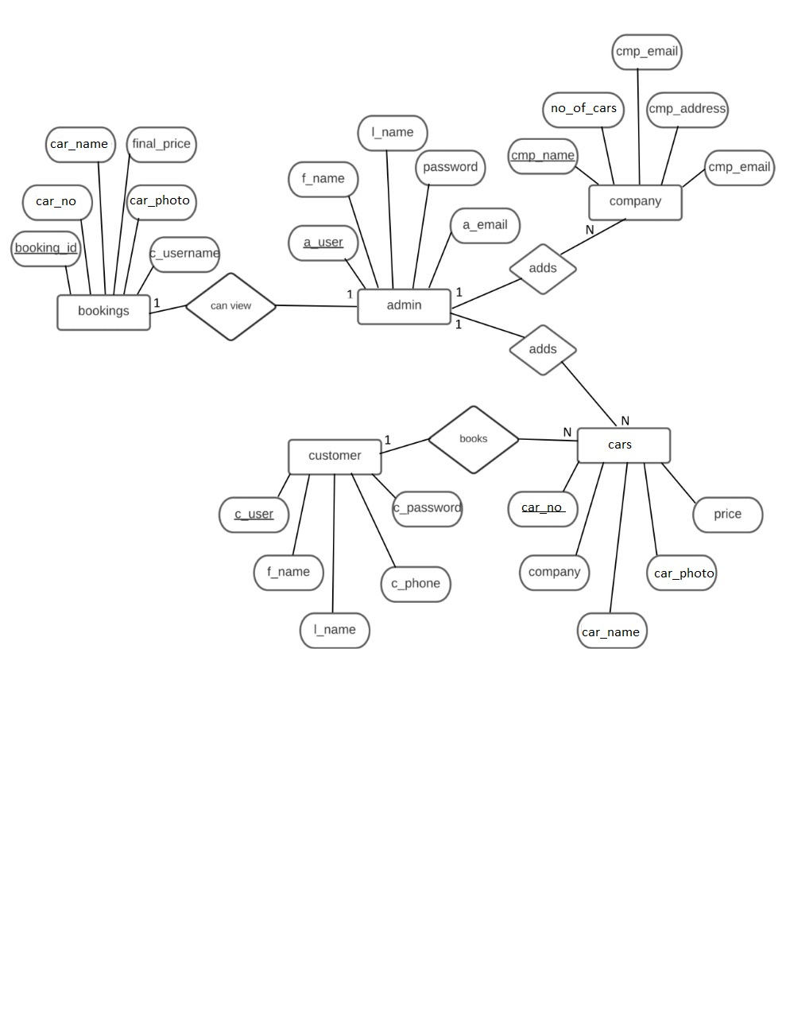

**2.2 Relational Schema Diagram**

**2.2.1 Schema**

customer

|  |  |  |  |  |  |  |
| --- | --- | --- | --- | --- | --- | --- |
| c_username | f_ name | l_name | c_phone | email | c_dob | c_password |

admin

|  |  |  |  |  |  |  |
| --- | --- | --- | --- | --- | --- | --- |
| a_username | f_name | l_name | a_phone | email | a_dob | password |

company

|  |  |  |  |  |  |
| --- | --- | --- | --- | --- | --- |
| cmp_logo | cmp_name | cmp_email | no_of_cars | cmp_address | cmp_desc |

cars

|  |  |  |  |  |  |  |  |
| --- | --- | --- | --- | --- | --- | --- | --- |
| car_photo | car_no | type | car_name | availability | company | price | desc |

bookings

|  |  |  |  |  |  |
| --- | --- | --- | --- | --- | --- |
| car_photo | c_username | booking_id | car_no | car_name | final_price |



**2.2.2 Schema Description**

A relational schema shows references among fields in the database. When a primary key is referenced in another table in the database, it is called a foreign key. This is denoted by an arrow with the head pointing to the referenced key attribute. A schema diagram helps organize values in the database. It also gives an idea of what order the tables should be created in.

**3. SYSTEM DESIGN**

**3.1 Table Description**

1.customer

|  |  |  |  |
| --- | --- | --- | --- |
| Sl. no | Name | Type | Description |
| 1. | c_username | VARCHAR (20) | Stores the username of customer. |
| 2. | f_name | VARCHAR (20) | Stores the first name of the customer. |
| 3. | l_name | VARCHAR (20) | Stores the last name of the customer. |
| 4. | c_phone | BIGINT(12) | Stores the phone number of the customer. |
| 5. | email | VARCHAR(30) | Stores the email of the customer. |
| 6. | c_dob | DATE | Stores the date of birth of the customer. |
| 7. | c_password | VARCHAR (10) | Stores the password of the customer. |

2. admin

|  |  |  |  |
| --- | --- | --- | --- |
| Sl. no | Name | Type | Description |
| 1. | a_username | VARCHAR (20) | Stores the username of the admin. |
| 2. | f_name | VARCHAR (20) | Stores the street name. |
| 3. | l_name | VARCHAR (20) | Stores the name of the city. |
| 4. | a_phone | BIGINT(12) | Stores the name of the state. |
| 5. | email | VARCHAR(30) | Stores the email of the admin. |
| 6. | a_dob | DATE | Stores the date of birth of the admin. |
| 7. | password | VARCHAR(20) | Stores the password of the admin. |

3. company

|  |  |  |  |
| --- | --- | --- | --- |
| Sl. no | Name | Type | Description |
| 1. | cmp_logo | VARCHAR (200) | Stores the name of the district. |
| 2. | cmp_name | VARCHAR (20) | Stores the address of the RTO. |
| 3. | cmp_email | VARCHAR(20) | Stores the email of the company. |
| 4. | no_of_cars | INT(200) | Stores the number of cars . |
| 5. | cmp_address | VARCHAR(200) | Stores the company address. |
| 6. | cmp_desc | VARCHAR(1000) | Stores the description of the company. |

4. cars

|  |  |  |  |
| --- | --- | --- | --- |
| Sl. no | Name | Type | Description |
| 1. | car_photo | VARCHAR (200) | Stores the photo of the cars. |
| 2. | car_no | INT(20) | Stores the car number. |
| 3. | type | VARCHAR (20) | Stores the engine type of cars. |
| 4. | car_name | VARCHAR (20) | Stores the name of the cars. |
| 5. | availability | VARCHAR (20) | Stores the availability of the cars. |
| 6. | company | VARCHAR (20) | Stores the name of the company. |
| 7. | price | INT(20) | Stores the price of the cars. |
| 8. | desc | VARCHAR (300) | Stores the description of the cars. |

5. bookings

|  |  |  |  |
| --- | --- | --- | --- |
| Sl. no | Name | Type | Description |
| 1. | car_photo | VARCHAR (200) | Stores the photo of the car. |
| 2. | c_username | VARCHAR (20) | Stores the name of the customer. |
| 3. | booking_id | VARCHAR (20) | Stores the booking id. |
| 4. | car_no | INT | Stores the car number. |
| 5. | car_name | VARCHAR (20) | Stores the name of the cars. |
| 6. | final_price | INT(20) | Stores the final price of the cars. |

**4. IMPLEMENTATION**

**4.1 Front-end Development**

**4.1.1 Hyper Text Markup Language**

HTML5is a mark-up language used for structuring and presenting content on the World

Wide Web. It is the fifth and current major version of the HTML standard. HTML5 includes detail processing models to encourage more interoperable implementations, it extends, improves and rationalizes the mark-up available for documents and introduces mark-up and application programming interfaces (APIs) for Complex Web applications. For the same reasons, HTML5is also a candidate for Cross platform mobile applications because it includes features design with low power devices in mind.

**4.1.2 Cascading Style Sheet**

Cascading Style Sheets (CSS) is a style sheet language used for describing the presentation of a document written in a mark-up language like HTML5.

**4.2 Back-end Development**

**4.2.1 Back-end Language- PHP**

PHP is the server-side scripting language designed primarily for web development but also used as a general-purpose programming language. PHP code may be embedded into HTML and HTML5 markup, or it can be used in combination with various web template systems, web content systems management and web Framework.

**4.2.2 Web Server- APACHE**

Web servers are used to serve Web pages requested by client computers. Apache is the most widely used web server software. Apache is the web server that processes requests and serves web assets and content via HTTP. Clients typically request and view Web pages using Web browser applications such as Firefox, Opera, Chromium, or Internet Explorer.

As a Web server, Apache is responsible for accepting directory (HTTP) requests from Internet users and sending them their desired information in the form of files and Web pages

**4.2.3 Database- MySQL**

MySQL Database Management System is used to store the user and product information

which is stored in the secondary storage device and can be altered any time. Normalized and efficient schema is used to avoid redundancy and inconsistency. The data is updated in real time.

**4.3 Insertion of records in the database**

Syntax:

INSERT INTO table_name

VALUES (value1, value2, value3, ...);

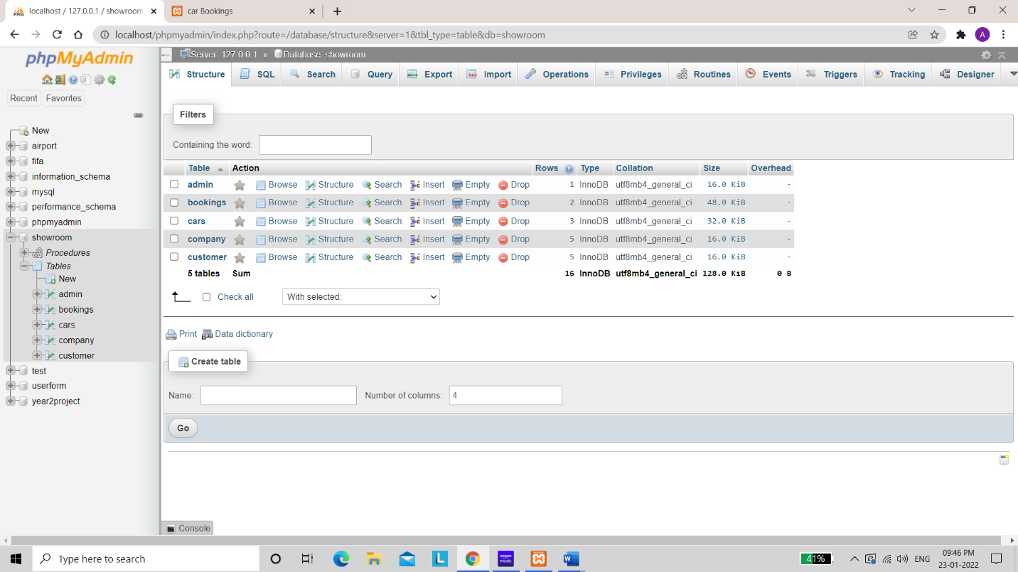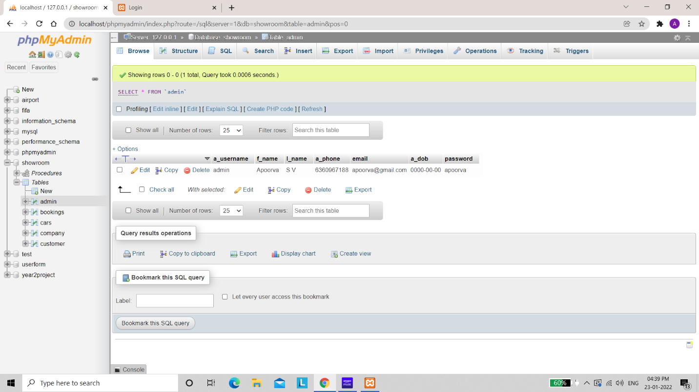

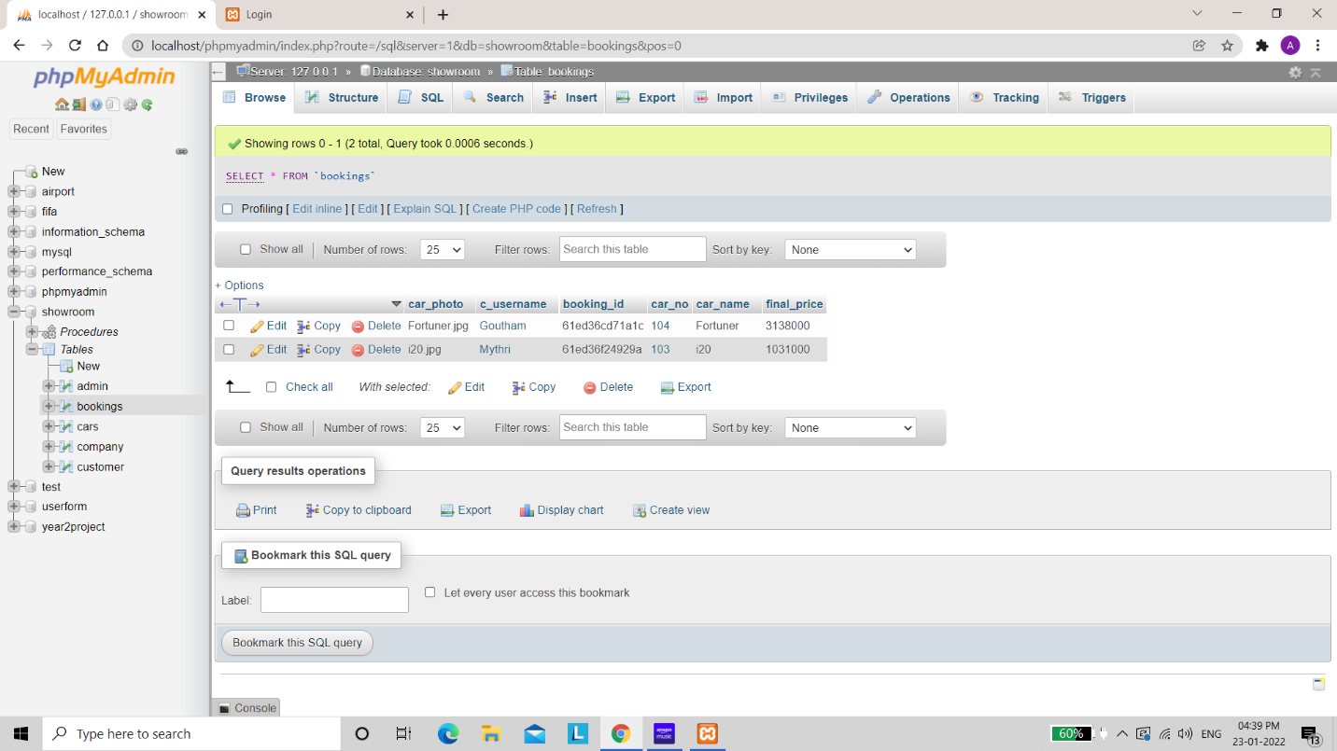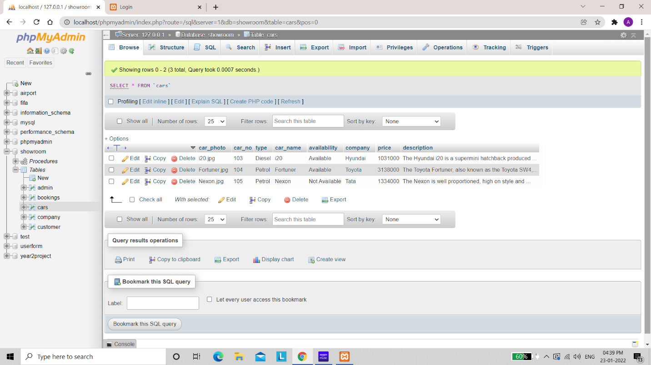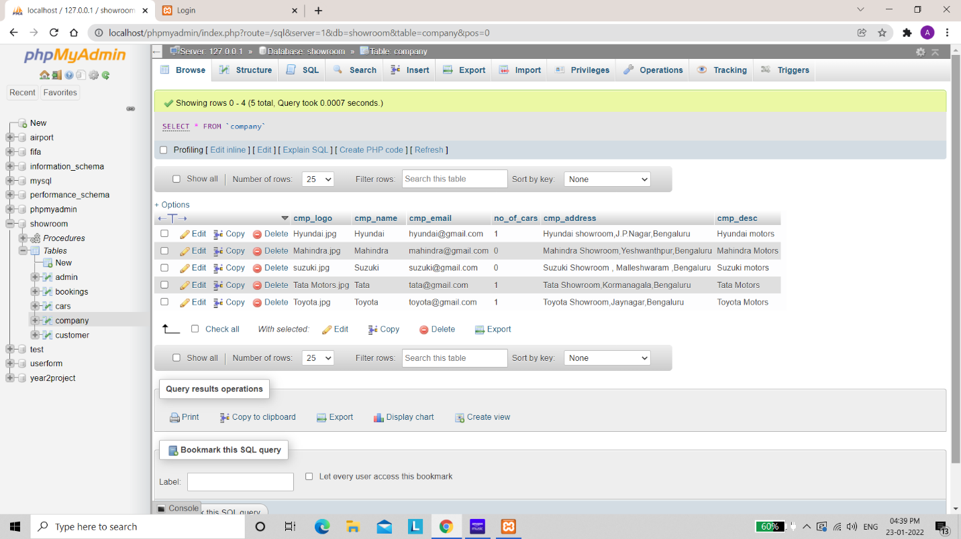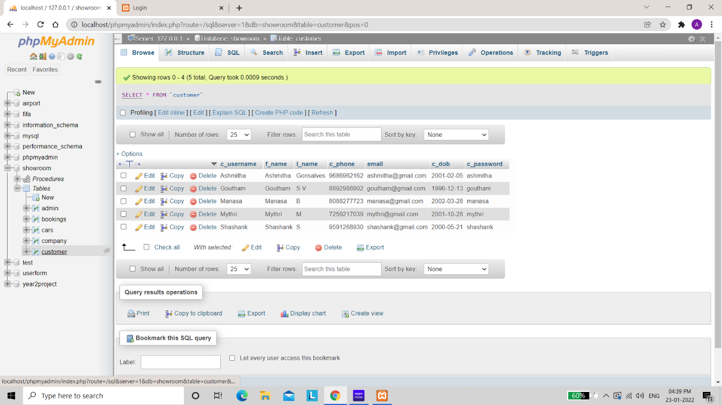

**4.4 Normalization**

**4.4.1 First Normal Form (1NF)**

For a table to be in the First Normal Form, it should follow the following 4 rules:

* It should only have single(atomic) valued attributes/columns.
* Values stored in a column should be of the same domain
* All the columns in a table should have unique names.
* And the order in which data is stored, does not matter.

**4.4.2 Second Normal Form (2NF)**

For a table to be in the Second Normal Form,

* It should be in the First Normal form.
* And, it should not have Partial Dependency.

**4.4.3 Third Normal Form (3NF)**

A table is said to be in the Third Normal Form when,

* It is in the Second Normal form.
* And, it doesn't have Transitive Dependency.

**NOTE**: The tables in our project are normalized until 3NF.

**5. STORED PROCEDURE**

A stored procedure provides an important layer of security between the user interface and the database. It supports security through data access controls because end users may enter or change data, but do not write procedures. It improves productivity because statements in a stored procedure only must be written once.

--STORED PROCEDURE.

DELIMITER //

CREATE PROCEDURE ViewBookings()

BEGIN

SELECT * FROM `bookings`;

END;

//

DELIMITER ;

**6. TRIGGERS**

A SQL trigger is a database object which fires when an event occurs in a database. We can execute a SQL query that will "do something" in a database when a change occurs on a database table such as a record is inserted or updated or deleted.

-- Trigger to increment the no_of_cars attribute of company table by 1 when a car information is added to the cars table.

CREATE TRIGGER add_car

AFTER INSERT ON cars

FOR EACH ROW

UPDATE company

SET no_of_cars =no_of_cars+1

WHERE cmp_name = new.company;

-- Trigger to decrement the no_of_cars attribute of company table by 1 when a car information is removed from the cars table.

CREATE TRIGGER remove_car

AFTER DELETE ON cars

FOR EACH ROW

UPDATE company

SET no_of_cars = no_of_cars-1

WHERE cmp_name = old.company;

**7. DISCUSSION OF CODE SEGMENT**

The whole project development was divided into two parts, the front-end development and the backend development. The front-end development was creating the Car Showroom Management website with user-friendly interface. The backend development was to access the database stored on the server side and updating the same. In this project, MySQL is used as the backend database. We have used HTML, CSS, JavaScript, Bootstrap for the front-end implementation. Next, PHP is used as server scripting language to access the database and update it.

The project is run on a local machine with the help of XAMPP application which provides Apache HTTP server and MySQL as the backend database. The database is accessed and updated using the MySQL queries in PHP scripts. The MySQL queries used to implement the project include SELECT, INSERT, DELETE, UPDATE and JOIN.

**8.RESULTS / SNAPSHOTS**

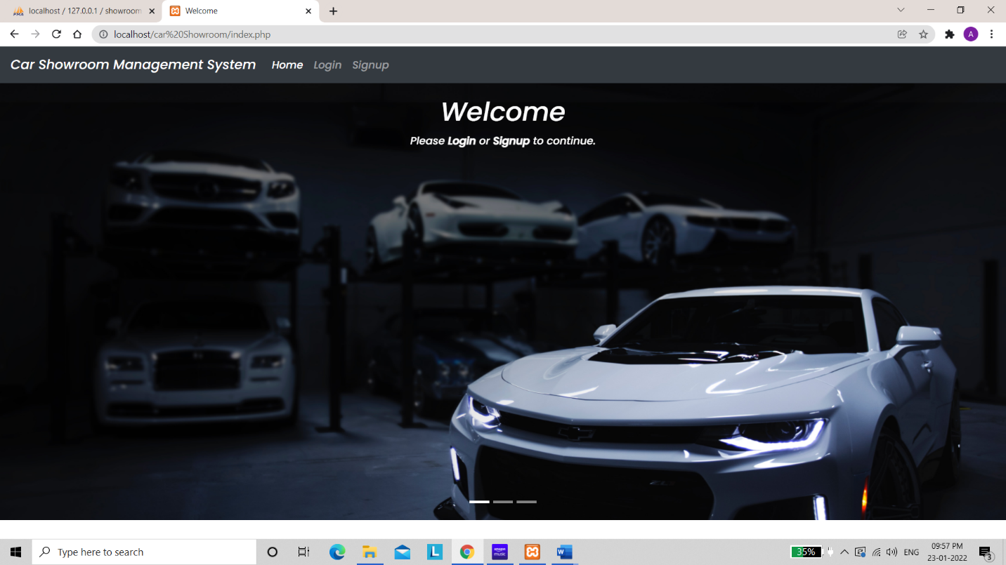

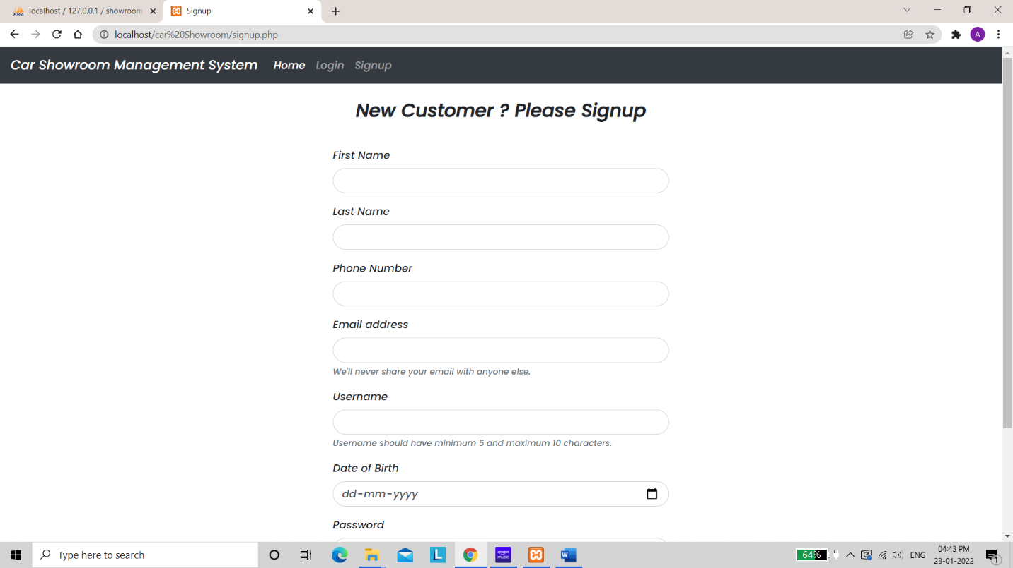

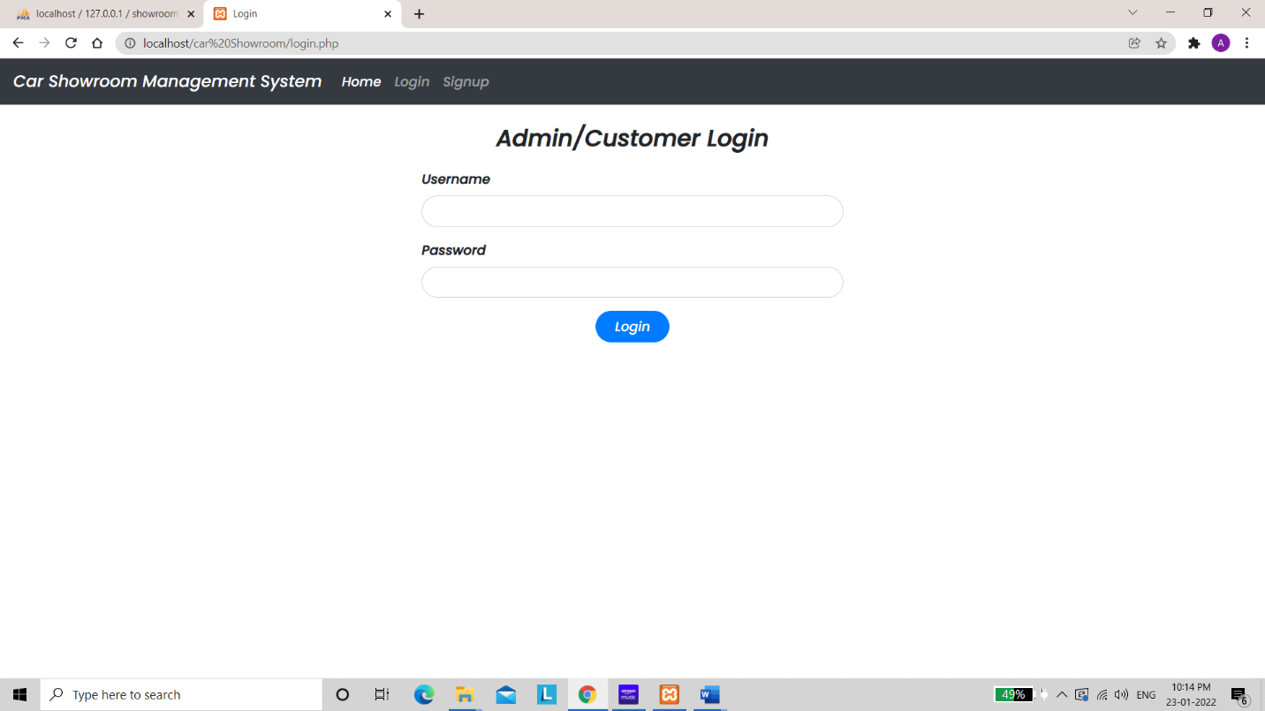

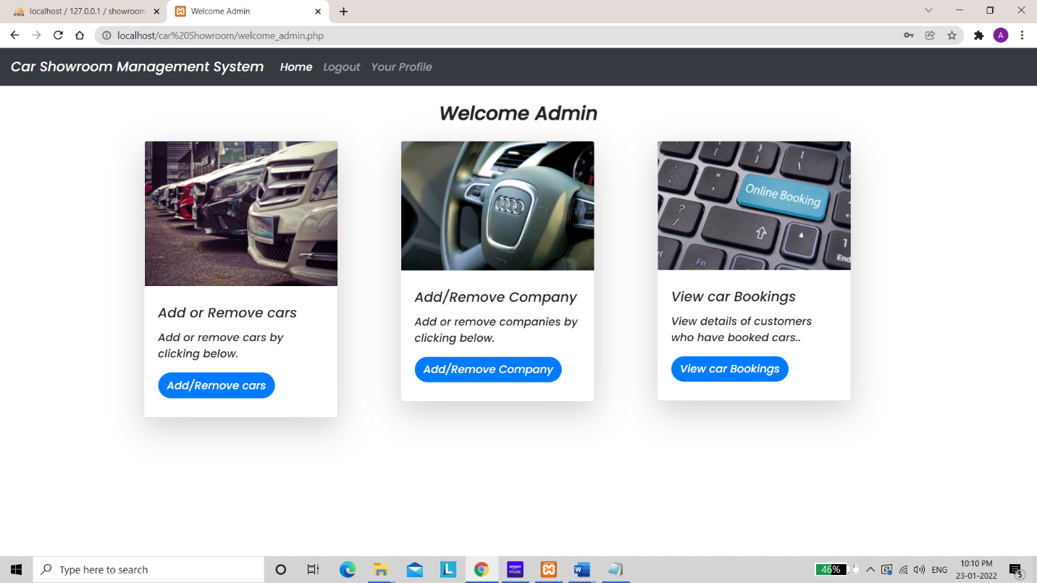

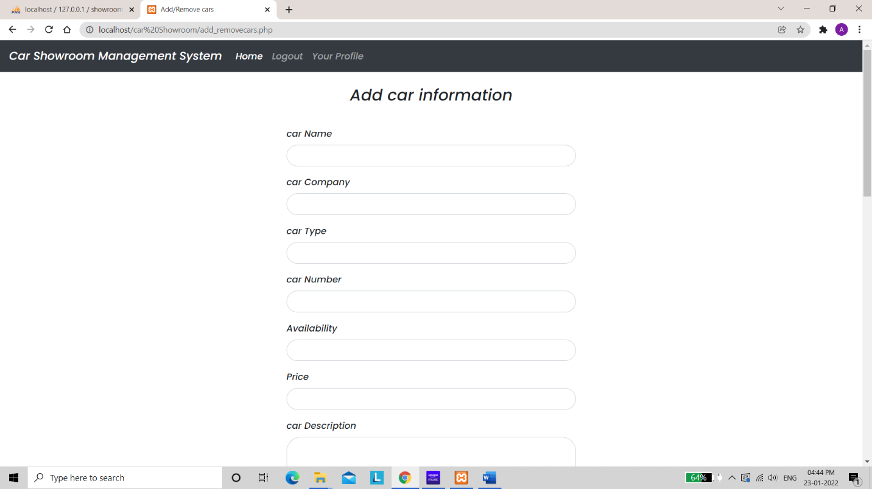

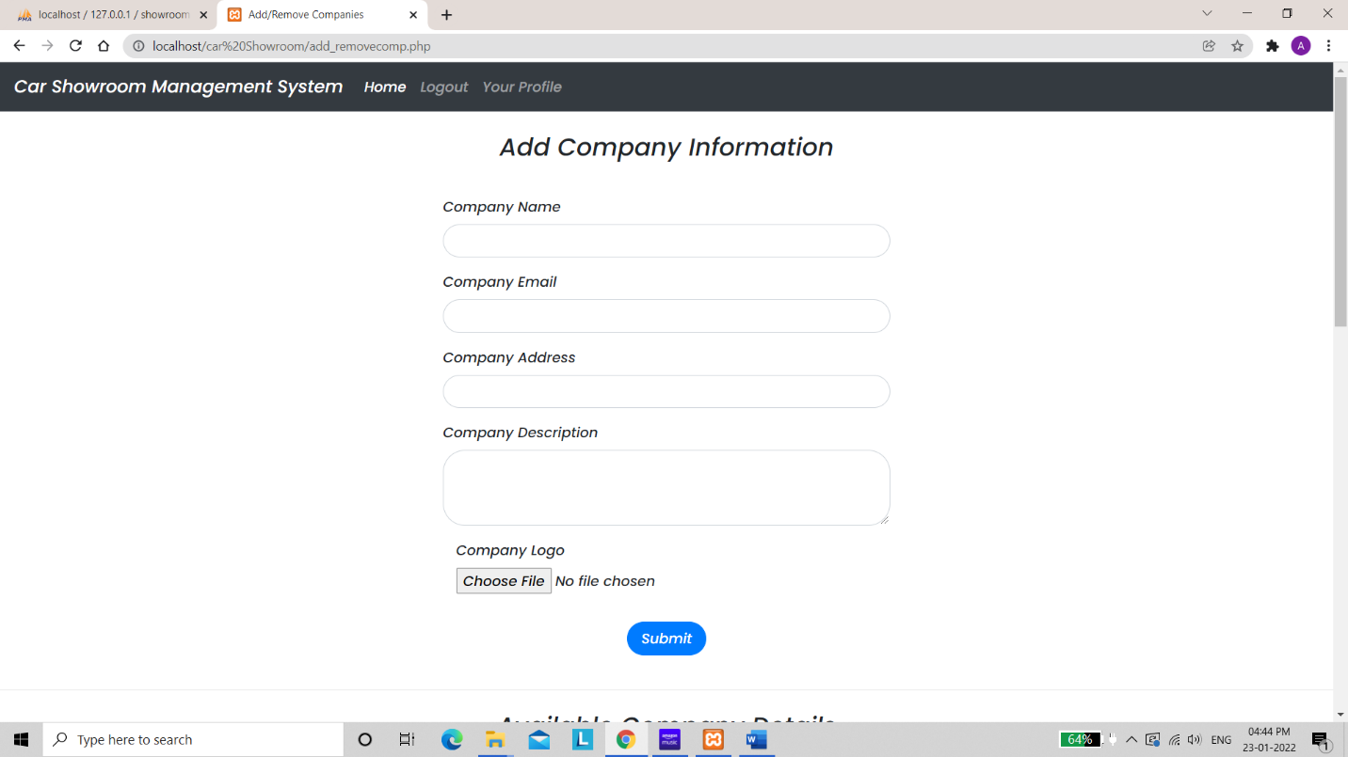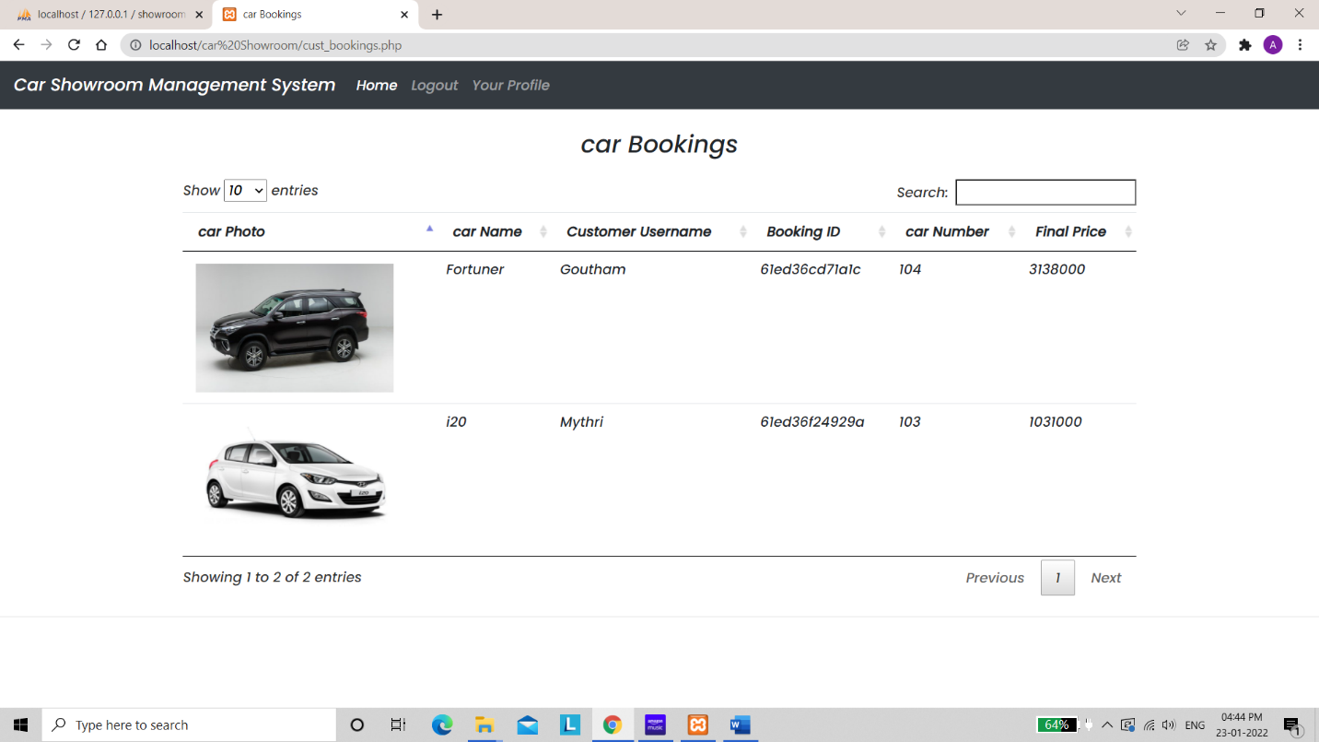

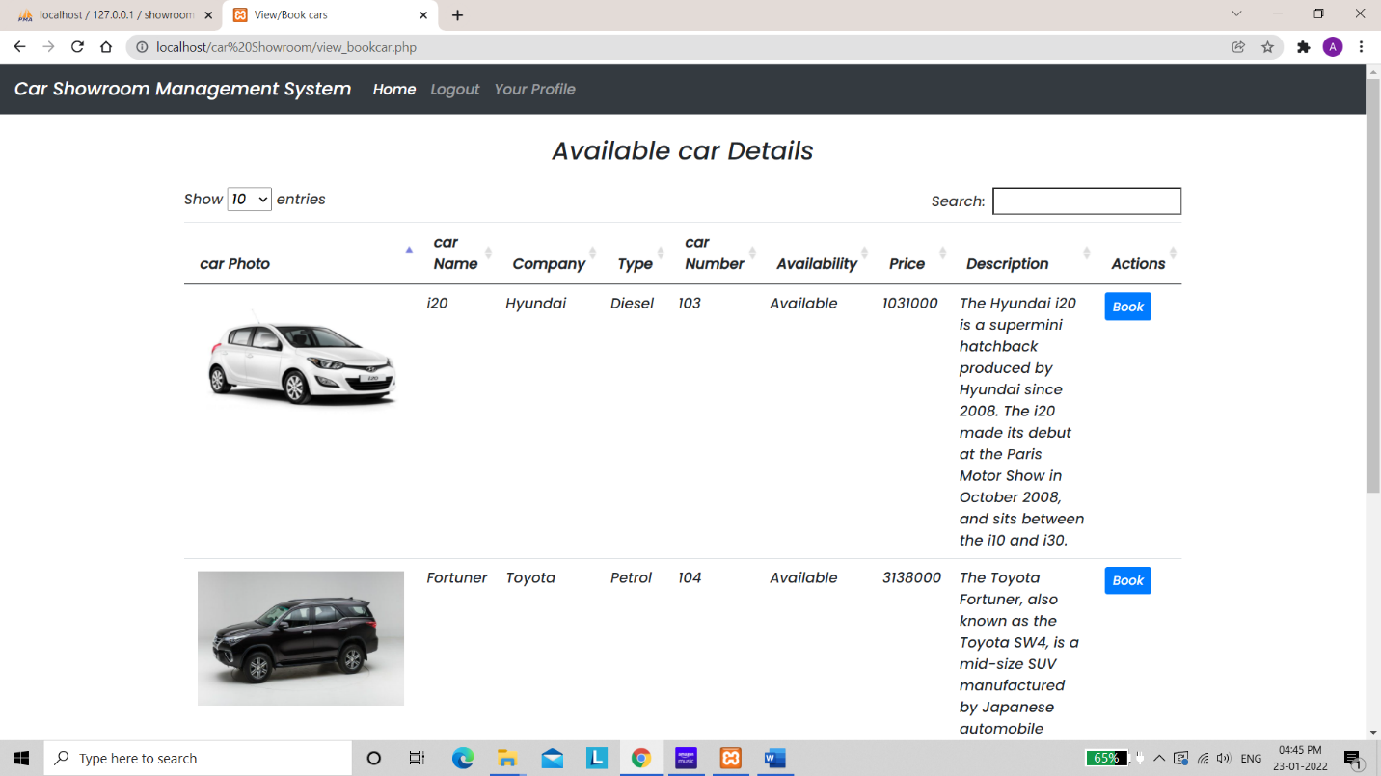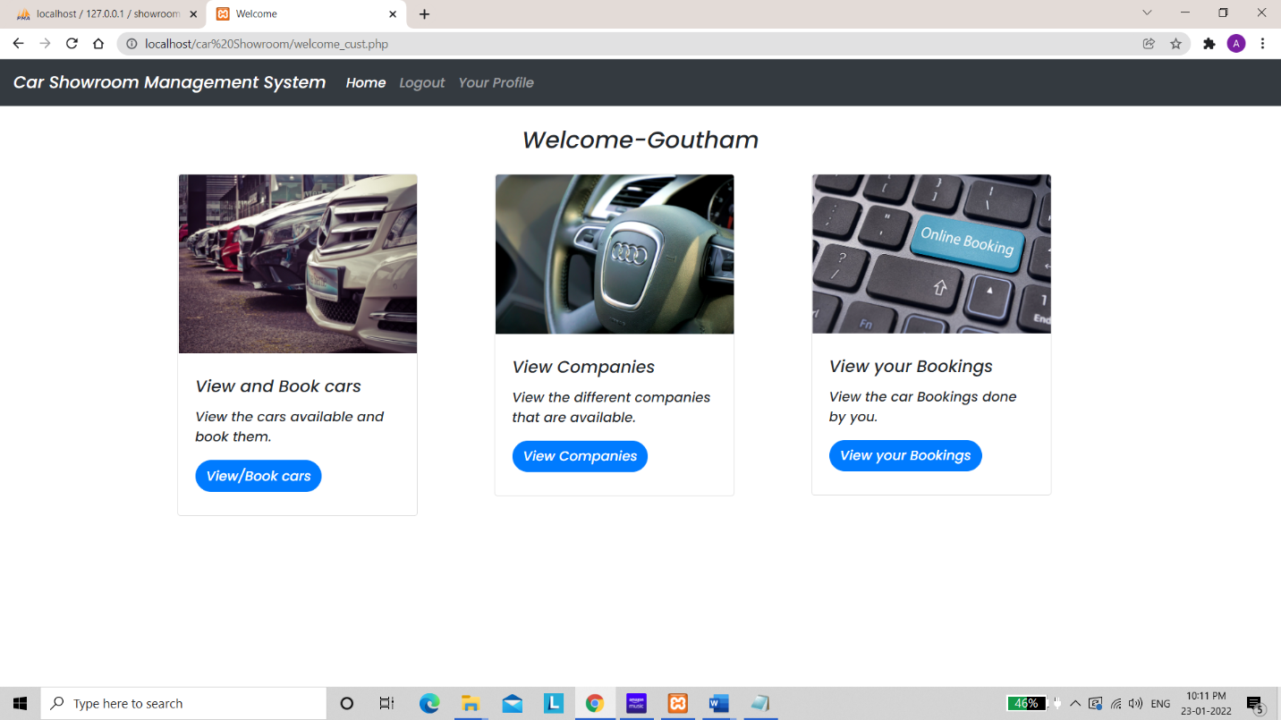

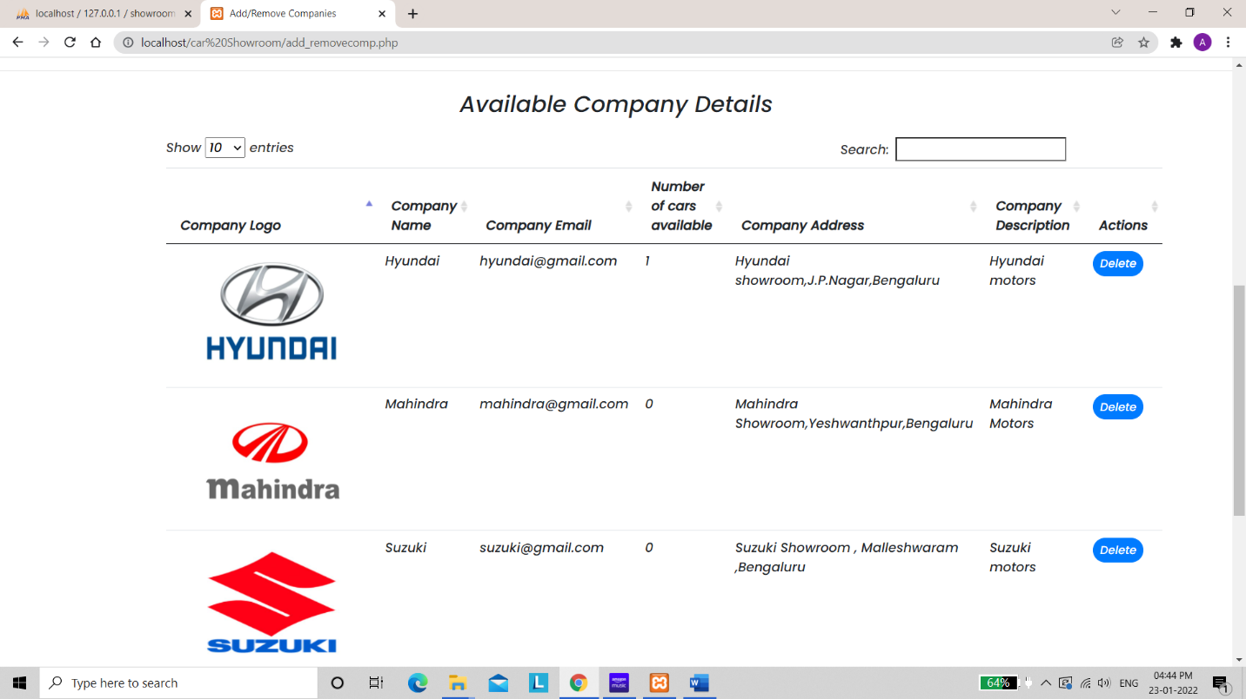



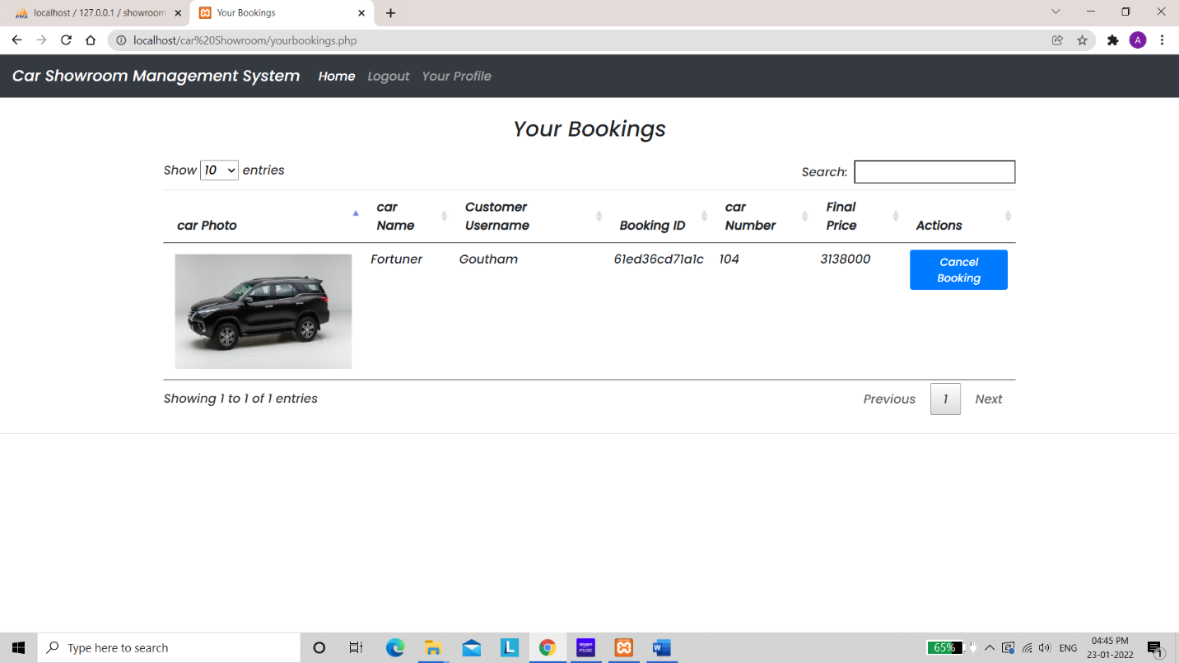

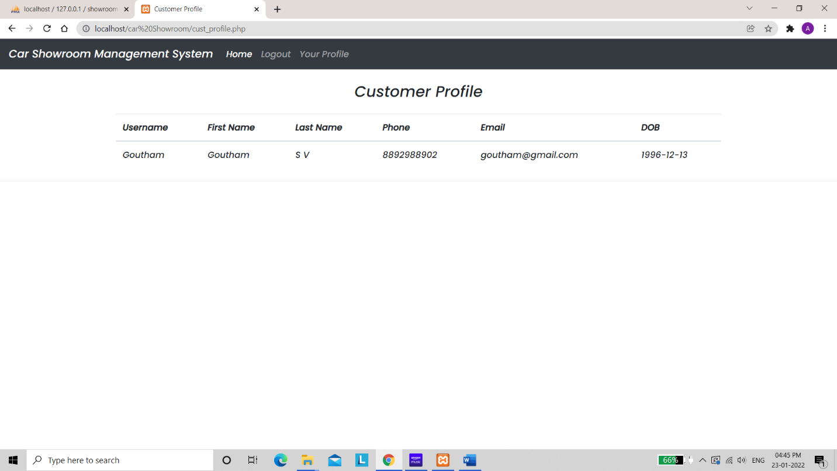

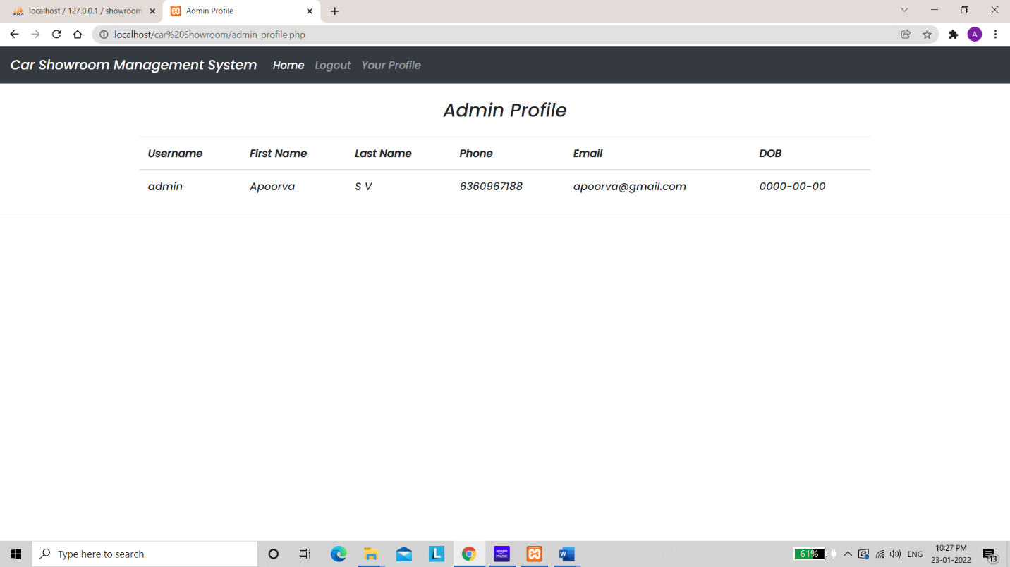

**9.CONCLUSION & FUTURE SCOPE**

We all know the importance of computerization. The world is moving ahead at lightning speed

and everyone is running short of time. One always wants to get the information and perform a task one desire(s) within a short period of time and too with amount of efficiency and accuracy.

Online Car Showroom management helps in

•Minimizing the manual records of the available cars and the companies.

•There will be more data integrity.

•Facilitating desired information display, very quickly, by retrieving

information from users.

Easier display of information of cars and the companies.

•To reduce manual efforts in activities that involved repetitive work.

•Updating and deletion of cars and companies and a huge amount of data will become easier.

**10. REFERENCES**

1. PHP reference (https://www.w3schools.com/php/).

2. Fundamental of Database Systems by Ramez Elmasri 7th Edition. 2017.

3. Database Systems by Ramakrishnan 3rd Edition, 2003.

4. PHP official Documentation (http://php.net/manual/en).

5. Sql Quick Reference (http://www.w3schools.com/sql/sql-quickref.asp)